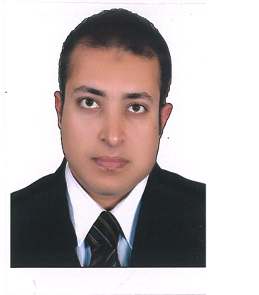

Ahmed Shoukry Mohamed
Contact Information | - : Mobile : +20 (0)1000470907  : +20 (0)1148281444  - E-mail : ashoukry28@GMail.com  - Home address : 23 st Mohamed Hassan – Feisal – Cairo, Egypt.
Objective | A challenging long term opportunity providing a bright career path. I intend on seizing the opportunity to prove my abilities as a quick learner and my potential as a hard worker.
Personal Information | - Date of Birth : 11th of April 1978  - Nationality : Egyptian  - Marital status : Married  - Gender : Male  - Military Service : Exempted
Education | - Technical and Commercial Institute: – Graduated 1998
Job Experience | Sapesco Transportation Manger  Jan2010-Present  Schlumberger Egypt Transportation Supervisor:  Jan 2005 –  - nsure Fleet associates comply with all safety (W/Shop & Personal) standards, monitor & report any non-conformance.  • Distribute daily workload to technicians.  • Daily/Weekly/Monthly Reports – review & submit on time.  • Communicate with vehicle user, determine problem(s) decide suitable course of action.  • Ensure periodic maintenance is carried out on vehicle fleet as per company policy.  • Monitor repair times, reducing vehicle downtime.  • Provide technical support to technicians when required.  • Evaluate technician’s performance, identify gaps and arrange suitable training/guidance.  • Review defect report - collate data, evaluate incidence rate & submit report to Fleet Engineer.  • Maintain ‘up to date’ library of W/Shop Technical Manuals/CD’s for all vehicles running within fleet.  • Review vehicle defects & classify cause of repair (maintenance, accident, or abuse).  - SWTS Requester.  - Organize all Heavy Transportation means for Kattamia.  - Review all Transportation invoices for all Suppliers.  - Consult other Egypt locations transportation issues.  - Organize the work Load between Schlumberger and the supplier.  - Responsible for the Rental vehicle for Testing Kattamia.  - Follow up with all SWTS orders; from the point of issuing the order till the supplier get the money  - Inspect all the Heavy trucks going from and to Kattamia Location  - Coordinate with the inspection subcontractor company (GLOBAL) in kattamia to do the final inception process and certificate.  - Organize to get any extra quotation that does not exist on the catalog.  Schlumberger : VDO & Drive Right Kattamia Supervisor  2003 – Dec 2004  - Down Load Record VDO & Drive Right data  - Install, Maintain and Repair to the VDO and Drive Right.  - Prepare Month Report for all Kattamia Vehicles.  - Defensive driving trainer  Schlumberger : OFS Supervisor Assistant  2001 - 2003  - Prepare all the OFS time sheet (Subcontractors)  - Coordinate with the Drivers and for-mans.  - Supervise the OFS workers  Bahgat Group: Material Division Manager Assistant  Feb 1999 – 2001  - Organize and coordinate the work between the store mans  - Receive the orders from the Showrooms; coordinate with the store to deliver the required items.  - Distribute the daily work load among the division works  Bahgat Group: Store man  Sept 1998 – Jan 1999  - Controlling in / out items from the store  - Organize and supervise the inventory Count System.  - All orders requester.  - Request the supplier quotations
Computer Skills  Training courses: | - Strong knowledge of Excel, Word, PowerPoint.  - Internet tools.  - Flexible to learn any software.  - Fire fighting basic course  - Risk assessment awareness session.  - Defensive driving  - Road risk assessment course.  - Task Risk Assessment..  - Rules to prevent and fight fire.
Command of languages | - Arabic : Mother tongue  - English : good
Personal highlight: | - Able to work under pressure  - Able to work and communicate well with people  - Active ,highly motivated and a team player  - Willing to learn.  References will be furnished upon request

